**DATA WAREHOUSING AND DATA MINING**

**PROJECT 1**

*TEAM 98*

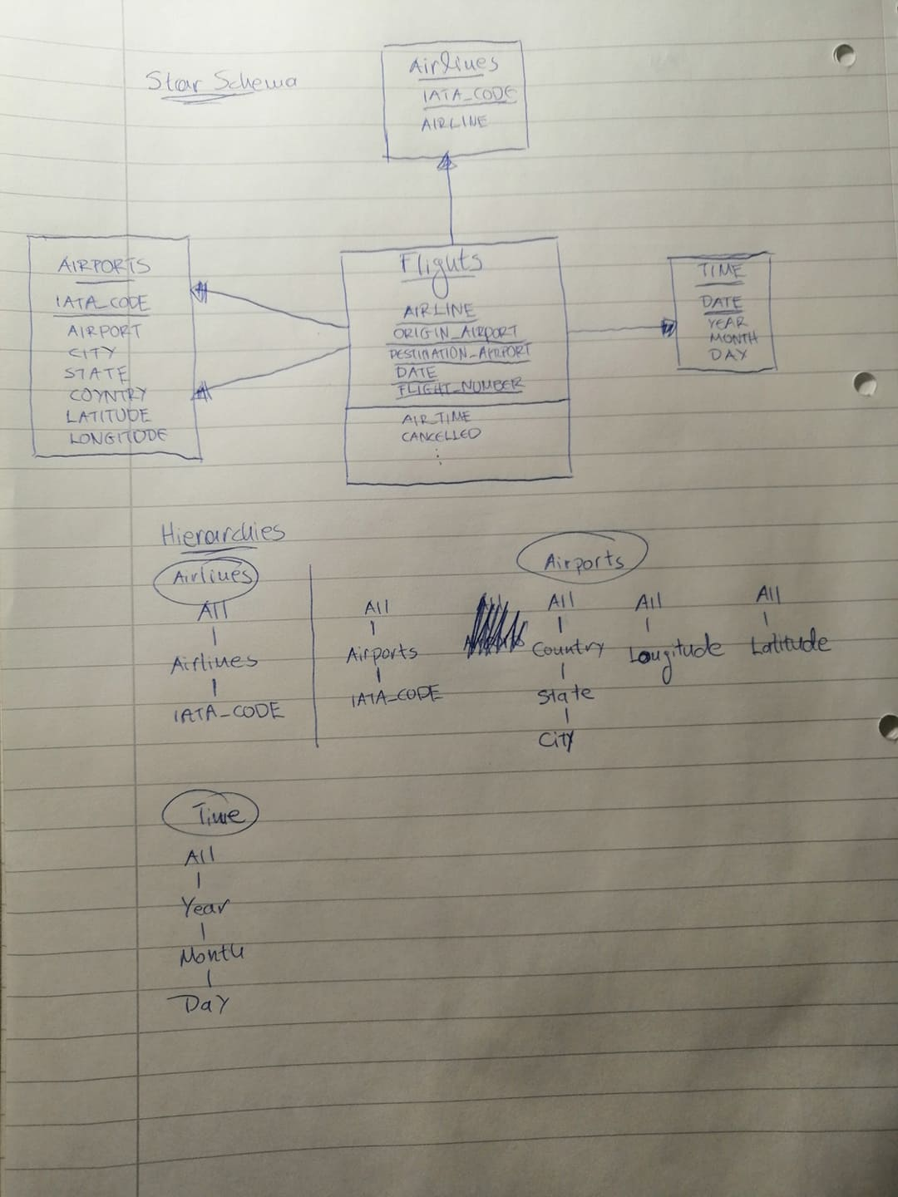

1. The drill-down is performed over All to air_time level.

Slice operation on the hierarchy Time for a single dimension air_time= MAX

1. The drill-down is performed over All to elapsed_time level on the Time hierarchy.

The drill-down is performed over All to airlines level on the Airlines hierarchy.

Slice operation on the hierarchy Time for a single dimension elapsed_time= AVG

1. The drill-down is performed over All to flight_number level.

Slice operation on the hierarchy Date for a single dimension Month= Feb.

1. The drill-down is performed over All to Month level.  
   The drill-down is performed over All to Airport level.

Dice operation for dimension Cancelled= 0 and COUNT(flight_number)= MAX

1. The drill-down is performed over All to Month level.  
   Slice operation for a single dimension Distance= COUNT.

**3)**

**REPORT 1:**

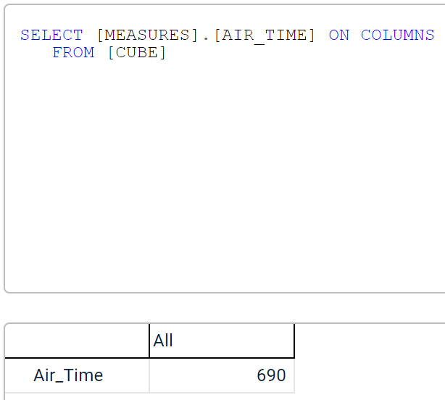

**REPORT 2:**

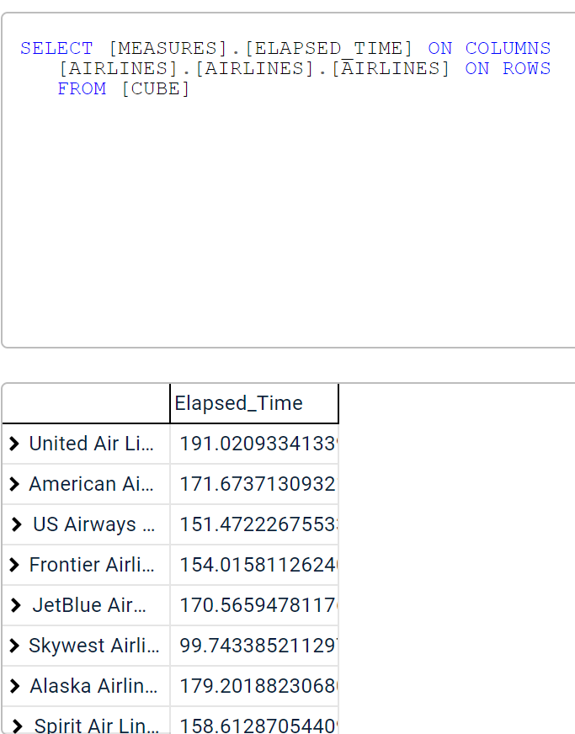

**REPORT 3:**

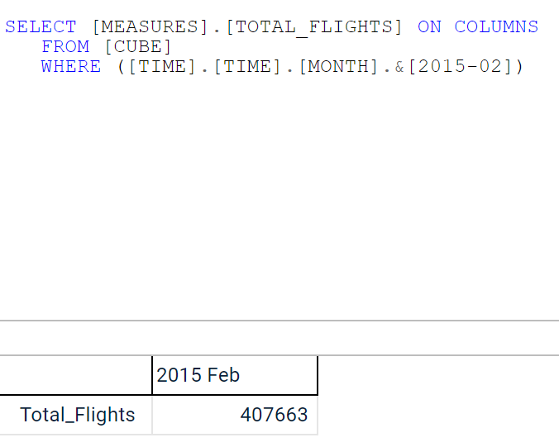

**REPORT 4:**

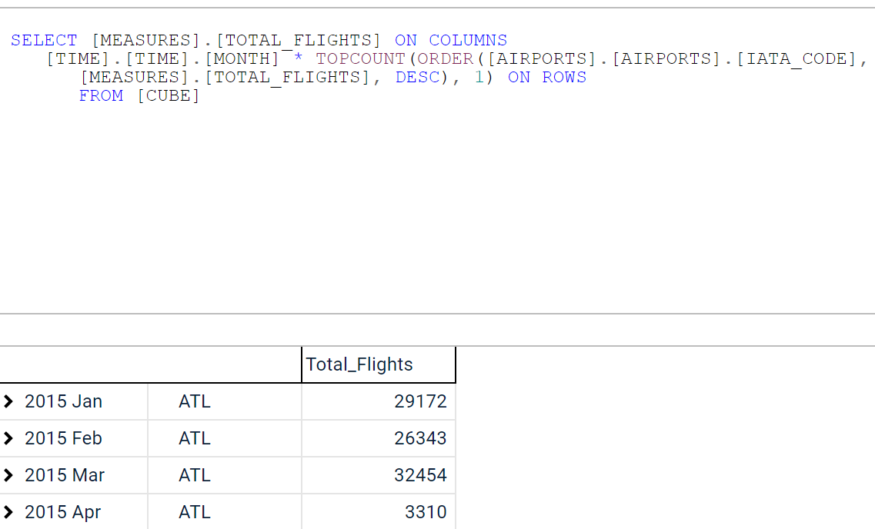

**REPORT 5:**

